RFM Analysis –

Identified different clusters

Receiving Campaigns and Redeeming Coupons

Does one segment use loyalty cards more than the other?

1. Coupon Redempt - Does one segment redeem coupons more than the other segments?

Yes

1. At what point of the campaign do most coupons get redeemed?
2. Are the most redeemable campaign common across all segments?

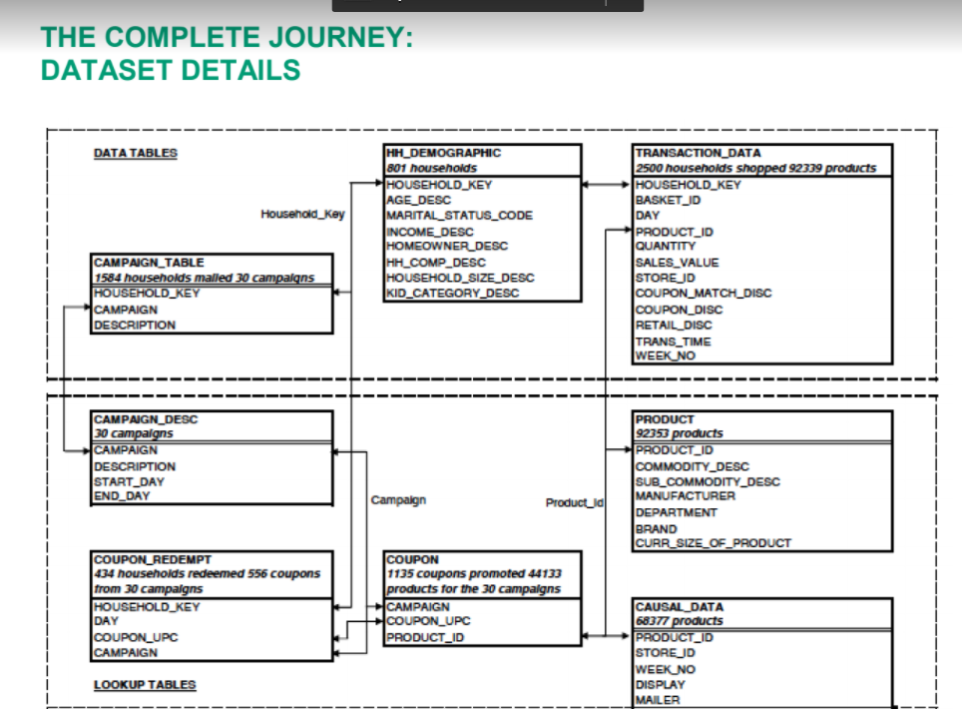

Campaign 15 ran the Longest –

|  |  |  |  |
| --- | --- | --- | --- |
| **Segment** | **RFM** | **Description** | **Marketing** |
| Best Customers | 111 | Bought most recently and most often, and spend the most | No price incentives, new products, and loyalty programs |
| Loyal Customers | X1X | Buy most frequently | Use R and M to further segment |
| Big Spenders | XX1 | Spend the most | Market your most expensive products |
| Almost Lost | 311 | Haven’t purchased for some time, but purchased frequently and spend the most | Aggressive price incentives |
| Lost Customers | 411 | Haven’t purchased for some time, but purchased frequently and spend the most | Aggressive price incentives |
| Lost Cheap Customers | 444 | Last purchased long ago, purchased few, and spent little | Don’t spend too much trying to re-acquire |

My Definitions:

Almost Lost – 3XX

Big Spenders – XX1

Lost Customers – 3 or 4

Loyal Customers – X1/2X

Lost Cheap Customers – ¾ X ¾

New Customers – ½ ¾ X

Do almost churned customers shop for different products than the other segments?

Are the almost churned/ churned customers shopping from a particular store – could be store specific

Are the big spenders / loyal customers shopping from certain stores?

Is there a particular brand that different segments are interested in?